Table of Contents

**Project Title: E-Connect – A Smart E-Learning Platform** 3

**1. Overview** 3

**2. Purpose of the Project** 3

**3. Objectives** 3

**4. Scope of the Project** 3

**5. Technologies Used** 3

**6. Expected Outcome** 3

1. Stakeholders and Their Requirements 4

Primary Stakeholders: 4

2. Feasibility Analysis 5

a. Technical Feasibility 5

b. Financial Feasibility 5

c. Operational Feasibility 5

3. High-Level Business Case 5

a. Problem Statement 6

b. Solution & Benefits 6

c. Competitive Advantage 6

d. Expected ROI (Return on Investment) 6

4. Key Risks and Constraints 6

a. Key Risks 6

b. Constraints 6

Conclusion 7

5. Work Breakdown Structure (WBS) 7

Level 1: Project: E-learning Platform Development 7

2. Task Dependencies and Sequencing 8

3. Resource Allocation (Team Roles and Responsibilities) 8

4. Timeline (Gantt Chart) 9

5. Budget Estimation 10

6. Risk Mitigation Strategies 10

Identified Risks: 10

2. Project Communication Plan 11

Stakeholders: 11

Communication Goals: 11

Communication Methods: 11

Communication Frequency: 12

7. Software Requirements Specification (SRS) 12

3.1 Introduction 12

3.2 System Overview 12

3.3 Requirements Collection Tools……………………………………………………………………………………….13-18

3.4 Functional Requirements 19

3.5 Non-Functional Requirements 20

3.6 External Interface Requirements 20

3.7 System Attributes 21

Execution Phase 21

Frontend Development 24

Backend Development 27

Third-Party Integrations: 34

Conduct Regular Team Meetings to Track Progress 34

Tools for Collaboration 35

3. Types of Testing 35

Challenges and Resolutions 35

Closure Phase 35

Evaluation Phase 38

Conduct a Post-Project Review 39

Process: 39

What challenges were faced and how were they addressed? 39

Lessons learned for future projects: 39

Conclusion 40

**Project Title: E-Connect – A Smart E-Learning Platform**

**1. Background**

E-Connect is an innovative e-learning platform designed to facilitate online education by providing interactive courses, assessments, and communication tools for learners and educators. The platform aims to bridge the gap between students and teachers, making education accessible anytime, anywhere.

**2. Problem Statement**

Many existing e-learning platforms lack interactivity, efficient course management, and real-time engagement, making online education less effective for both students and educators. Students struggle with tracking their progress, while educators face challenges in creating and managing courses. Additionally, accessibility and scalability issues hinder seamless learning experiences. **E-Connect** aims to address these challenges by providing an interactive, user-friendly, and scalable platform that enhances digital learning through multimedia content, assessments, live sessions, and progress tracking.

**2. Purpose of the Project**

The purpose of E-Connect is to offer a structured and user-friendly digital learning experience. The platform will support diverse learning methods, including video lessons, quizzes, assignments, and live sessions. It will empower educators with tools to create and manage courses efficiently while allowing students to track their learning progress.

**3. Objectives**

* Develop a robust and scalable e-learning platform with an intuitive user interface.
* Provide students with a seamless learning experience through multimedia content, discussions, and assessments.
* Enable educators to create, manage, and monitor courses effortlessly.
* Integrate features like progress tracking, certification, and real-time interaction.
* Ensure security, scalability, and responsiveness across devices.

**4. Scope of the Project**

E-Connect will cater to students, teachers, and administrators by offering:

* **User Authentication & Role Management** (Students, Teachers, Admins)
* **Course Creation & Management** (Video lectures, PDFs, quizzes, assignments)
* **Live Sessions & Discussion Forums**
* **Progress Tracking & Certification**
* **Secure Payment Integration for Paid Courses** (if applicable)
* **Mobile-Friendly & Responsive Design**

**5. Technologies Used**

* **Backend:** Django (Python)
* **Frontend:** React.js / Django Templates
* **Database:** PostgreSQL / MySQL
* **Authentication:** JWT / OAuth
* **Cloud & Storage:** AWS / Firebase / Local Server

**6. Expected Outcome**

E-Connect will provide a scalable and feature-rich online learning environment that enhances the educational experience for both students and instructors. It will help institutions, educators, and learners collaborate effectively in a digital space.

## ****1. Stakeholders and Their Requirements****

### ****Primary Stakeholders:****

#### **1. Students**

* Access to a wide range of online courses, available anytime and anywhere.
* Interactive learning materials, including video lectures, quizzes, and assignments.
* Progress tracking to monitor learning milestones and achievements.
* Certification upon course completion for career and academic advancements.
* Peer discussion forums for collaborative learning and problem-solving.
* Mobile-friendly access for learning on the go.

#### **2. Teachers/Instructors**

* A user-friendly interface to create and manage courses effectively.
* Tools for hosting live classes, conducting discussions, and engaging with students.
* Automated and manual assessment grading options.
* Student performance analytics to track progress and provide feedback.
* Course monetization opportunities for paid content.
* Secure content management to protect intellectual property.

#### **3. Administrators**

* Overall platform management, including user registration, course approval, and issue resolution.
* Enforcement of security measures and compliance with data protection laws.
* Moderation of content and discussions to maintain a positive learning environment.
* Generation of detailed reports and analytics for platform optimization.

#### **4. Educational Institutions (Optional Stakeholders)**

* Institutional branding and customization options for a personalized experience.
* Centralized management of multiple courses and student enrollments.
* Integration with existing Learning Management Systems (LMS).
* Ability to track student engagement and performance.

#### **5. Investors/Sponsors (If Applicable)**

* Revenue generation opportunities through course sales, subscriptions, and partnerships.
* Scalability potential for future growth and expansion.
* A robust business model ensuring long-term profitability.

## ****2. Feasibility Analysis****

### ****a. Technical Feasibility****

* **Technology Stack:** Django (backend), React.js (frontend), PostgreSQL (database).
* **Security Measures:** Implementation of authentication protocols (JWT/OAuth), encryption, and secure transactions.
* **Scalability:** Support for increasing users and content, with cloud-based storage solutions like AWS/Firebase.
* **Integration:** Compatibility with third-party APIs for video hosting, payment processing, and content management.
* **User Experience:** Responsive design ensuring seamless usability on desktops, tablets, and mobile devices.

### ****b. Financial Feasibility****

* **Development Costs:**
  + Domain registration and web hosting.
  + Software licensing and third-party integrations.
  + Initial platform development and testing.
* **Operational Costs:**
  + Ongoing maintenance, updates, and security enhancements.
  + Customer support and content moderation.
  + Marketing and promotional activities.
* **Revenue Streams:**
  + Subscription-based access for premium users.
  + One-time course purchases and certification fees.
  + Institutional collaborations for bulk enrollment.
  + Advertisement placements and sponsorships.

### ****c. Operational Feasibility****

* **User Registration & Management:** Automated onboarding, role-based access control.
* **Support & Maintenance:** Dedicated admin panel for troubleshooting and issue resolution.
* **Training & Adoption:** Intuitive user interface with minimal learning curve, along with help guides and tutorials.

## ****3. High-Level Business Case****

### ****a. Problem Statement****

Traditional education methods often lack flexibility, accessibility, and engagement. With the growing demand for online education, there is a need for an efficient and scalable e-learning platform that can cater to diverse learners worldwide.

### ****b. Solution & Benefits****

* **For Students:** A flexible, engaging, and interactive learning experience that supports self-paced and instructor-led courses.
* **For Instructors:** A streamlined content creation and management system that allows easy monetization of courses.
* **For Institutions:** A scalable and centralized digital learning solution that can integrate with existing systems.

### ****c. Competitive Advantage****

* AI-powered recommendations for personalized learning paths.
* Gamification features to enhance student engagement.
* Adaptive learning methodologies based on student performance analytics.
* Secure and scalable architecture ensuring data protection and smooth operation.

### ****d. Expected ROI (Return on Investment)****

* Break-even expected within 2-3 years through subscriptions, partnerships, and direct course sales.
* Sustainable revenue growth through continuous platform improvement and feature enhancements.

## ****4. Key Risks and Constraints****

### ****a. Key Risks****

* **Technical Challenges:** Potential issues with platform stability, performance, and data security.
* **Market Competition:** Strong competition from established e-learning platforms such as Coursera, Udemy, and Khan Academy.
* **User Adoption:** Difficulty in attracting users and ensuring long-term engagement.
* **Data Privacy & Compliance:** Adhering to global data protection regulations such as GDPR and COPPA.

### ****b. Constraints****

* **Budget Constraints:** Initial funding limitations affecting development and marketing efforts.
* **Resource Availability:** Requirement for skilled developers, content creators, and support staff.
* **Timeframe:** Estimated 6-12 months for full platform development, testing, and launch.

## ****Conclusion****

E-Connect aims to revolutionize online education by providing an accessible, interactive, and scalable e-learning platform. By addressing technical, financial, and operational challenges proactively, the project will ensure a seamless learning experience for students and educators. The platform’s business model, competitive edge, and risk mitigation strategies position it for long-term success in the e-learning industry.

## 5. ****Work Breakdown Structure (WBS)****

The WBS breaks the project into smaller, manageable tasks. Here’s a high-level structure for an e-learning platform:

### Level 1: Project: E-learning Platform Development

1. **Initiation Phase**
   * Define project goals
   * Scope document creation
   * Stakeholder identification
   * Risk assessment
2. **Planning Phase**
   * System requirements gathering
   * Platform design (UI/UX)
   * Tech stack selection
   * Development environment setup
3. **Development Phase**
   * Backend development (Django, database, API)
   * Frontend development (UI, integration with backend)
   * User authentication and authorization
   * Content management system (CMS) integration
   * Payment gateway integration (if needed)
4. **Testing Phase**
   * Unit testing
   * Integration testing
   * User acceptance testing (UAT)
   * Security testing
5. **Deployment Phase**
   * Deployment to staging environment
   * Final deployment to production server
   * Post-deployment monitoring
6. **Maintenance Phase**
   * Bug fixes
   * Platform updates
   * User feedback collection

### 2. ****Task Dependencies and Sequencing****

Dependencies refer to tasks that cannot start until another task is finished. Here’s a basic dependency flow:

* **Initiation Phase** → **Planning Phase**
* **Planning Phase** (Tech stack selection) → **Development Phase** (Backend and Frontend development)
* **Backend and Frontend Development** → **Testing Phase**
* **Testing Phase** → **Deployment Phase**
* **Deployment Phase** → **Maintenance Phase**

### 3. ****Resource Allocation (Team Roles and Responsibilities)****

#### 1. **Project Manager (PM)**

* Oversees the entire project.
* Manages resources, timelines, and ensures that milestones are met.
* Communicates with stakeholders.

#### 2. **Frontend Developer(s)**

* Designs and develops the user interface.
* Ensures responsive design and smooth user experience.
* Works with backend developers for API integration.

#### 3. **Backend Developer(s)**

* Develops server-side logic (using Django).
* Manages databases (models, migrations).
* Develops APIs for frontend integration.

#### 4. **UI/UX Designer**

* Designs wireframes, mockups, and user flow.
* Works closely with frontend developers to implement the design.

#### 5. **Quality Assurance (QA) Tester**

* Performs manual and automated testing.
* Conducts unit tests, integration tests, and user acceptance testing.

#### 6. **DevOps Engineer**

* Manages deployment process.
* Configures servers (both staging and production).
* Ensures security measures are in place.

#### 7. **Content Manager**

* Handles content creation and management.
* Uploads course materials and organizes learning paths.

#### 8. **Security Specialist**

* Focuses on platform security, including user data protection and secure payment processing.

### 4. ****Timeline (Gantt Chart)****

A Gantt chart visually represents the project timeline, with dependencies. Here’s a rough estimation of the timeline for a 2-month project:

| **Phase** | **Duration** | **Dependencies** |
| --- | --- | --- |
| **Initiation** | 1 week | None |
| **Planning** | 2 weeks | Initiation |
| **Development** | 3 weeks | Planning |
| **Testing** | 1 weeks | Development |
| **Deployment** | 1 week | Testing |
| **Maintenance** | Ongoing | Deployment |

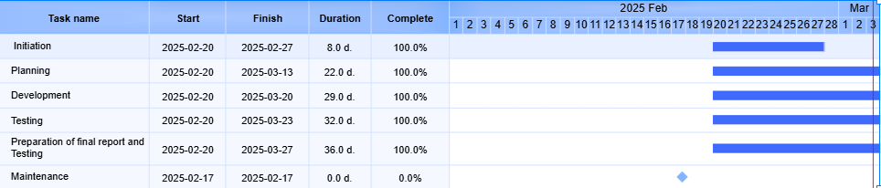

### 5. ****Budget Estimation****

The budget will depend on the team size, tools, and software used. Below is a sample estimate for a small-to-medium-sized e-learning platform development:

| **Category** | **Estimated Cost** |
| --- | --- |
| **Personnel Costs** | $500(for 2-3 months) |
| **Tech Stack (Licenses/Tools)** | $50 |
| **Server Costs** | $200(AWS/Heroku/Other) |
| **Design/Content Tools** | $200 |
| **Marketing and Launch** | $500 |
| **Contingency** | $500 |
| **Total Estimated Budget** | **$1,960** |

## 6. ****Risk Mitigation Strategies****

### Identified Risks:

1. **Technical Risks**
   * **Risk**: Choosing the wrong technology stack or framework.
     + **Mitigation**: Conduct thorough research and prototyping before finalizing the tech stack. Consult with experienced developers and architects.
2. **Resource Availability**
   * **Risk**: Team members may become unavailable due to personal reasons or competing projects.
     + **Mitigation**: Plan for backup resources, cross-train team members, and set clear project deadlines.
3. **Scope Creep**
   * **Risk**: Uncontrolled expansion of project features after initiation.
     + **Mitigation**: Establish clear project goals and features at the beginning and follow a change control process for new feature requests.
4. **Delayed Deliverables**
   * **Risk**: Delays in one phase (like development) could affect the entire timeline.
     + **Mitigation**: Set realistic deadlines and milestones. Use Agile or Scrum methodology for flexibility in adjusting timelines.
5. **Security Breaches**
   * **Risk**: Sensitive user data may be exposed or compromised.
     + **Mitigation**: Ensure encryption for sensitive data, implement secure coding practices, conduct regular security audits, and adhere to GDPR or other relevant privacy regulations.
6. **Budget Overrun**
   * **Risk**: The project might exceed the estimated budget.
     + **Mitigation**: Allocate a contingency budget, track expenses closely, and avoid scope creep.
7. **User Adoption and Engagement**
   * **Risk**: Low user engagement after deployment.
     + **Mitigation**: Conduct user testing during the development phase, collect feedback, and incorporate user-centered design.

## 2. ****Project Communication Plan****

Clear and effective communication is essential for project success. Below is a communication plan that ensures all stakeholders are informed at the right times.

### Stakeholders:

1. **Manager (PM)**
2. **Developers (Frontend & Backend)**
3. **UI/UX Designer**
4. **QA Tester**
5. **Security Specialist**
6. **Content Project Manager**
7. **Client/Stakeholders**
8. **End-users**

### Communication Goals:

* Ensure the flow of timely, accurate, and relevant information.
* Provide clarity on tasks, deadlines, and expectations.
* Manage changes effectively and keep all parties updated.

### Communication Methods:

1. **Email**:
   * For official communications, weekly reports, and status updates.
   * Weekly project updates to stakeholders.
2. **Slack/Microsoft Teams**:
   * Real-time team communication (quick clarifications, daily stand-ups).
   * Channels for different aspects (design, development, testing).
3. **Project Management Tools (Trello/Jira)**:
   * Task tracking, deadlines, and updates.
   * Assign tasks, track progress, and mark milestones.
4. **Video Calls (Zoom/Google Meet)**:
   * Weekly check-in meetings.
   * Sprint reviews and retrospectives (if using Agile).
5. **Documentation (Confluence/Google Docs)**:
   * Maintain project documentation, including design specs, technical specs, testing results, and user feedback.

### Communication Frequency:

* **Daily Stand-ups** (15-minute calls for developers, testers, and PM).
* **Weekly Status Reports**: Sent via email and discussed in a meeting.
* **Monthly Stakeholder Review**: Detailed progress review.
* **Ad-hoc meetings**: For urgent decisions or escalations.

## 7. ****Software Requirements Specification (SRS)****

### 3.1 ****Introduction****

* **Purpose**: This document defines the software requirements for the e-learning platform to ensure the system meets the needs of all stakeholders, including learners, instructors, and administrators.

### 3.2 ****System Overview****

* The system will be a web-based platform providing online courses, quizzes, and certification for users. It will have user authentication, payment gateway integration, and a content management system (CMS) for instructors.

**3.3 Requirements Collection Tools for the E-Learning Platform**

**1. Questionnaires**

Purpose: To Gather quantitative data from potential users, including learners, instructors, and administrators.

Target Audience:

• Learners (students enrolling in courses)

• Instructors (educators creating and managing courses)

• Admins (managing users, reports, payments, etc.)

• **Learner Questionnaire**

**Authentication & User Experience**:

1. How do you prefer to log in to an online learning platform?

☐ Email & Password

☐ Google Login

☐ Facebook Login

☐ Other (please specify)

2. Have you ever faced difficulty resetting your password on an e-learning platform?

☐ Yes

☐ No

☐ Sometimes

**Course Interaction & Completion:**

3. What type of learning materials do you prefer? (Check all that apply)

☐ Video Lectures

☐ PDFs / eBooks

☐ Interactive Quizzes

☐ Live Sessions

☐ Discussion Forums

4. How important is immediate feedback after a quiz?

☐ Very Important

☐ Important

☐ Neutral

☐ Not Important

5. Would you prefer certifications for completed courses?

☐ Yes

☐ No

**Payment & Transactions**:

6. Which payment methods do you commonly use? (Check all that apply)

☐ Credit/Debit Card

☐ PayPal

☐ Mobile Wallet

☐ Bank Transfer

7. Have you ever faced security concerns when making an online payment?

☐ Yes

☐ No

**Notifications & User Engagement:**

8. What notifications would you like to receive? (Check all that apply)

☐ Course Updates

☐ Promotions & Discounts

☐ Certification Completion

☐ New Course Recommendations

• **Instructor Questionnaire**

**Course Management & Content Creation:**

1. How do you currently create and manage online courses?

☐ LMS (Learning Management System)

☐ Standalone Websites

☐ Video Hosting Platforms (YouTube, Vimeo)

2. What type of assessments do you prefer for evaluating learners?

☐ Multiple-Choice Questions

☐ True/False Questions

☐ Short Answer Questions

☐ Essay-Based Assignments

3. How important is multimedia support (video, PDFs) for delivering your course content?

☐ Very Important

☐ Important

☐ Neutral

☐ Not Important

**Platform Features & Security:**

4. What reporting tools would help you track learner progress effectively?

5. Do you require role-based access for managing teaching assistants or co-instructors?

☐ Yes

☐ No

________________________________________

• Admin Questionnaire

**User & Role Management:**

1. What actions should an admin be able to perform? (Check all that apply)

☐ Reset User Passwords

☐ Create/Edit/Delete Courses

☐ Manage Payments

☐ Generate User Reports

2. What level of reporting detail is required?

☐ User Activity Reports

☐ Financial Transactions Report

☐ Course Completion Reports

Security & Compliance:

3. What security measures do you expect in the platform?

☐ Two-Factor Authentication (2FA)

☐ Role-Based Access Control (RBAC)

☐ GDPR Compliance for User Data

________________________________________

**2. Interview Guidelines**

**Purpose: Collecting in-depth qualitative insights about the platform’s usability, functionality, and user expectations.**

**Methodology: Conduct structured interviews with different user groups.**

Learner Interview Guide

1. Walk me through your experience using online learning platforms. What do you like/dislike?

2. What motivates you to complete an online course?

3. What challenges have you faced while enrolling, making payments, or accessing courses?

4. How do you feel about receiving notifications on course updates, promotions, and certifications?

5. What payment concerns do you have when purchasing online courses?

**Instructor Interview Guide**

1. What challenges do you face when managing online courses?

2. How do you handle assessments, and what improvements do you wish to see?

3. What kind of reports and analytics would help you improve teaching effectiveness?

**Admin Interview Guide**

1. How do you currently manage e-learning platforms?

2. What reporting and user management features would make your job easier?

3. What security policies and compliance standards must the platform adhere to?

________________________________________

**3. Focus Groups**

**Purpose: Gather collective feedback and validate proposed features before implementation.**

Participants:

• 5-8 learners

• 3-5 instructors

• 2-3 admins

Topics for Discussion:

• Preferred authentication methods

• Payment security concerns and trust factors

• Course interaction features (video lectures, quizzes, certificates)

• Reporting tools and admin requirements

________________________________________

**4. Observational Studies**

**Purpose: To identify usability challenges by observing users interact with an existing e-learning platform.**

What to Observe?

1. Login & Authentication:

o How easily can users register or log in?

o How many users face issues resetting their passwords?

2. Course Navigation:

o How intuitive is it for users to enrol and access courses?

o How much time does it take for a user to find a specific course?

3. Quiz & Assessment Interaction:

o Do users struggle with certain quiz formats?

o How do users react to immediate feedback after a quiz?

4. Payment & Checkout:

o How many users abandon checkout before completing a purchase?

o Are there any difficulties with payment options?

________________________________________

**5. Competitive Analysis**

Purpose: To analyse leading e-learning platforms to identify best practices and feature gaps.

Comparison Criteria:



________________________________________

### 3.4 ****Functional Requirements****

1. **User Authentication**
   * Users must be able to register, log in, and reset passwords.
   * Users should be able to use social logins (Google, Facebook).
   * Admins should have the ability to reset any user's password.
2. **Course Management**
   * Instructors must be able to create, edit, and manage courses.
   * Each course will have multimedia support (videos, PDFs).
   * Learners must be able to enroll, view, and complete courses.
3. **Payment Integration**
   * The platform should support multiple payment methods (credit card, PayPal, etc.).
   * Payment processing must be secure and comply with PCI DSS.
4. **Quiz and Assessment**
   * Users must be able to take quizzes associated with courses.
   * Quizzes should support multiple question types (multiple choice, true/false, short answer).
   * Learners should receive immediate feedback after completing assessments.
5. **Admin Panel**
   * Admins should be able to manage user roles (student, instructor, admin).
   * Admins should be able to generate reports for user activity, course progress, and financial transactions.
6. **User Profile**
   * Users must have a profile page showing their enrolled courses, progress, and certifications.
7. **Notifications**
   * Users must receive email notifications for course updates, promotions, or certifications.

### 3.5 ****Non-Functional Requirements****

1. **Performance**:
   * The platform must support at least 1,000 concurrent users.
   * Average page load time must be under 3 seconds.
2. **Scalability**:
   * The system must scale horizontally as the number of users grows.
3. **Security**:
   * All data, including user information and payment details, must be encrypted using SSL/TLS.
   * Implement role-based access control to ensure data privacy.
4. **Availability**:
   * The platform must be available 99.9% of the time.
5. **Usability**:
   * The platform must be responsive and accessible on all devices (desktop, tablet, mobile).
   * User interfaces should be intuitive and follow modern design principles.
6. **Compliance**:
   * The platform must comply with GDPR or any applicable data protection regulations.

### 3.6 ****External Interface Requirements****

1. **Web Interface**: The platform will be a responsive web app, accessible via standard browsers (Chrome, Firefox, Safari).
2. **Payment Gateway**: Integration with third-party services (e.g., Stripe, PayPal).
3. **Email Service**: Integration with an email service provider for notifications.

### 3.7 ****System Attributes****

* **Reliability**: High availability and data consistency.
* **Maintainability**: The system should be modular to facilitate updates and feature additions.
* **Portability**: Should work on multiple cloud platforms (AWS, Google Cloud, Azure).

## Execution Phase

**Use Cases**

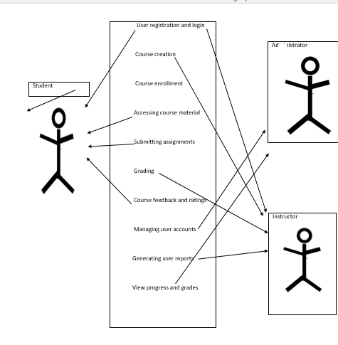

**Use Cases description**

**1. User Registration and Login**

Actors: Student, Instructor

- Description: Users can create an account by providing necessary information (e.g., name, email, password). They can log in to access their profiles and courses.

- Preconditions: User must have internet access.

- Postconditions: User is registered and can log in to the platform.

**2. Course Creation**

Actors: Instructor

- Description: Instructors can create new courses by providing details such as course title, description, duration, and uploading course materials (e.g., videos, documents).

- Preconditions: Instructor must be logged in.

- Postconditions: New course is created and available for enrollment.

**3. Course Enrollment**

Actors: Student

- Description: Students can browse available courses and enroll in them. They can view course details before enrolling.

- Preconditions: User must be logged in and have access to the course.

- Postconditions: Student is enrolled in the course and can access course materials.

**4. Accessing Course Materials**

Actors: Student

- Description: Students can access course materials, including lessons, assignments, quizzes, and additional resources.

- Preconditions: Student must be enrolled in the course.

- Postconditions: Student can view and interact with course materials.

**5. Submitting Assignments**

Actors: Student

- Description: Students can submit assignments for evaluation. They can upload files or provide text responses.

- Preconditions: Student must be enrolled in the course and the assignment must be available.

- Postconditions: Assignment is submitted and marked for grading.

**6. Grading Assignments**

Actors: Instructor

- Description: Instructors can review submitted assignments, provide feedback, and assign grades.

- Preconditions: Instructor must be logged in and have access to the assignments.

- Postconditions: Assignments are graded, and feedback is provided to students.

**.7 Viewing Progress and Grades**

Actors: Student

- Description: Students can view their progress in courses, including completed lessons, grades for assignments, and quiz scores.

- Preconditions: Student must be logged in.

- Postconditions: Student has access to their performance metrics.

8**. Course Feedback and Ratings**

Actors: Student

- Description: Students can provide feedback and rate courses they have completed.

- Preconditions: Student must be enrolled in the course and have completed it.

 - Postconditions: Feedback is recorded and can be viewed by other users.



**9. Managing User Accounts**

Actors: Administrator

- Description: Administrators can manage user accounts, including creating, updating, and deleting user profiles.

- Preconditions: Administrator must be logged in.

- Postconditions: User accounts are managed as per administrative requirements.

10. **Generating Reports**

Actors: Administrator, Instructor

- Description: Administrators and instructors can generate reports on course enrollments, student performance, and overall platform usage.

- Preconditions: User must be logged in with appropriate permissions.

- Postconditions: Reports are generated and can be exported or viewed.

**DATA FLOW DIAGRAMS**

**Level 0 DFD**

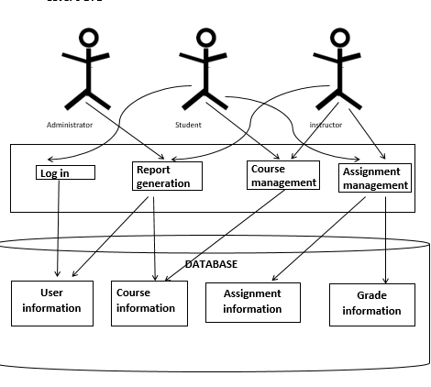

The system comprises processes such as Login, Course Management, Assignment Management, and Report Generation. Data is stored in a central Database, including Course Information, User Information, Assignment Information, and Grade Information. Data flows show interactions between actors and processes, such as students accessing courses, instructors managing assignments, and administrators generating reports. Overall, it illustrates how users interact with the system to manage courses, assignments, and generate reports, with data stored centrally in the database to facilitate these interactions

**LEVEL 1 DFD**

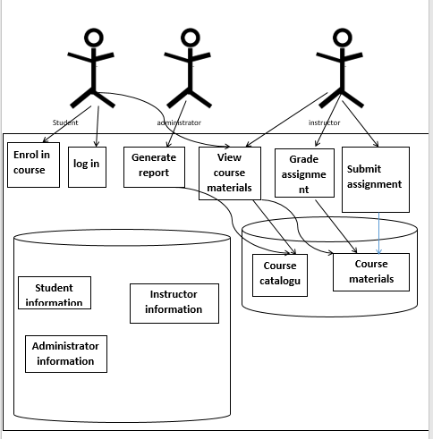

The system manages Course Information and User Information through separate databases. Processes include Login, Enroll in Course, View Course Materials, Submit Assignment, Grade Assignment, and Generate Report. Data flows show interactions between actors and processes, such as students enrolling in courses, instructors grading assignments, and administrators generating reports. Overall, it illustrates how users interact with the system to access course materials, submit assignments, and perform administrative tasks, with data stored in the database facilitating these interactions

**Entity Relationship Diagram.**

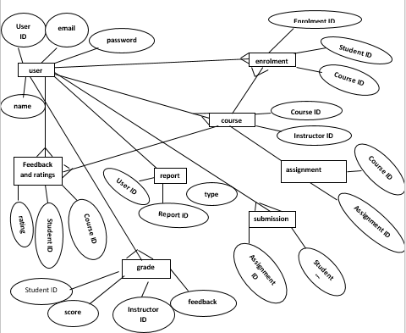

Represents individuals interacting with the system.

Attributes include user_id (unique identifier), username, email, password, and role (e.g., student, instructor, administrator).

Course: Represents academic courses offered within the system. Attributes include course_id (unique identifier) and course name.

Assignment: Represents tasks or assessments assigned to students within a course. Attributes include assignment_id (unique identifier), title and course_id (foreign key referencing Course entity).

Grade: Represents grades or scores assigned to students for completing assignments. Attributes include instructor_id (unique identifier), score, and references to assignment_id (foreign key referencing Assignment entity) and student_id.

Enrollment: Represents the enrollment of users (students) in courses. Attributes include enrollment_id (unique identifier), and references to user_id and course_id (foreign keys referencing User and Course entities, respectively).

Relationships:

User-Enrollment: Many users can be enrolled in multiple courses, and each enrollment is associated with one user and one course.

Course-Enrollment: Many courses can have multiple enrollments, indicating the participation of multiple users (students) in a course.

Course-Assignment: Each course can have multiple assignments, facilitating the management of course assessments and tasks.

Assignment-Grade: Each assignment can have multiple grades, representing the grading of the assignment submissions by different students.

Overall, this ER diagram depicts the relationships between users, courses, assignments, grades, and enrollments within the E Learning Platform, providing a structured representation of the system's data model

1. Develop the System Based on Planned Requirements

### Frontend Development

- Design a user-friendly interface for students, teachers, and administrators.

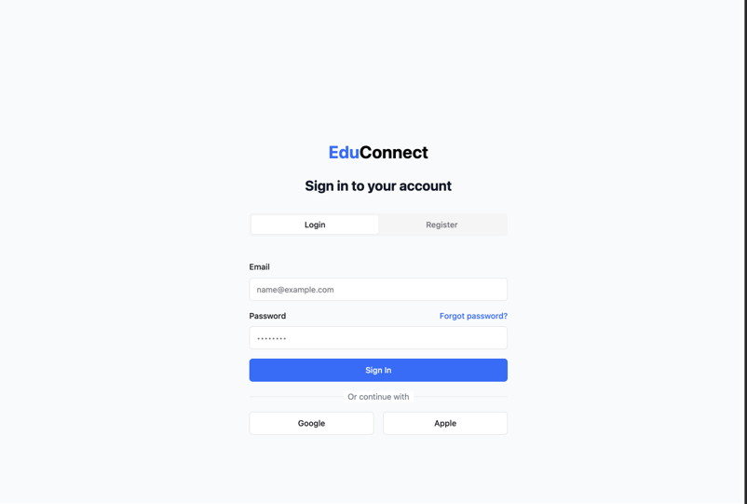

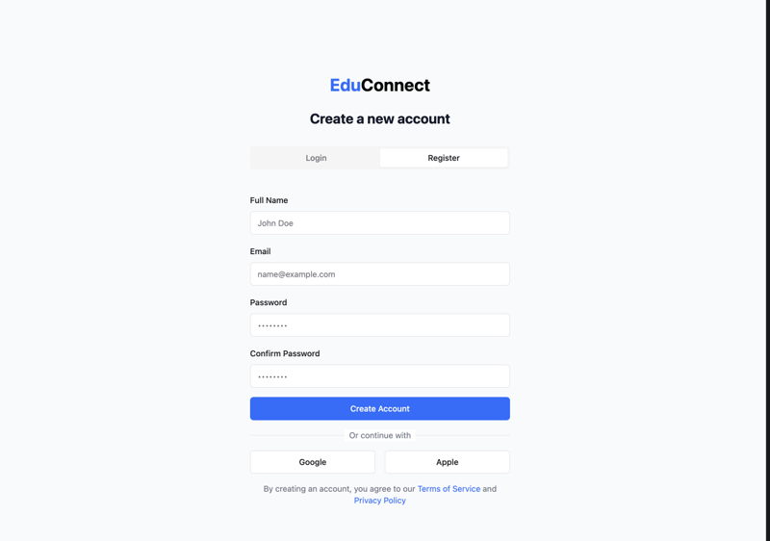

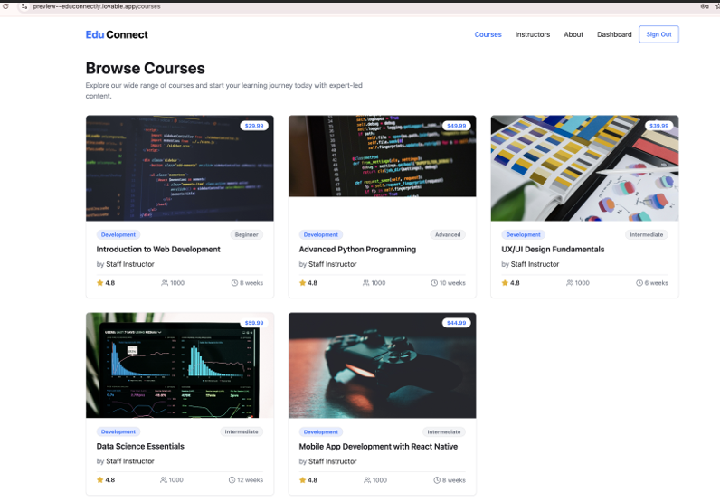 - Using **React.js** or **Angular** for responsive and interactive UI.

- Ensure accessibility and compatibility across devices (desktop, tablet, mobile).

### 

### Backend Development

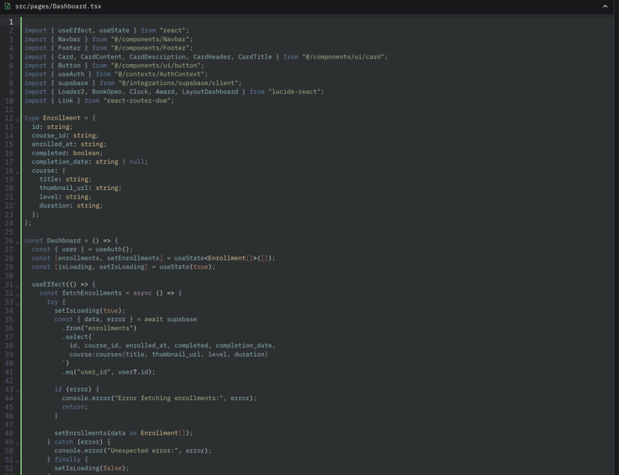

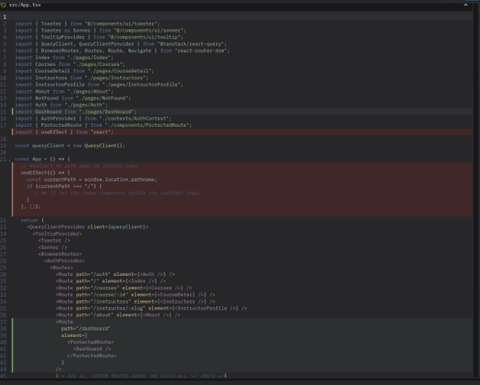



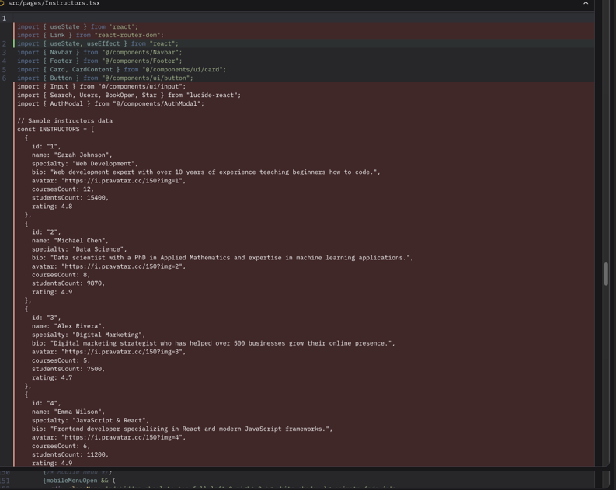

Use a robust backend framework like **Node.js**, **Django**, or **Ruby on Rails**.

- Implement APIs for seamless communication between frontend and backend.

Integration of a database

Integrating a database into the **E-Connect e-learning platform** is a critical step to store, manage, and retrieve data efficiently. The database will handle user information, course content, assessments, progress tracking, and more. Here's a short introduction to the process:

**Database Integration Overview**

1. **Purpose**:
   * Store and manage structured data (e.g., user profiles, courses, grades).
   * Enable seamless data retrieval and updates for the platform's functionality.
2. **Database Selection**:
   * Choose a database based on requirements:
     + **Relational Database (e.g., MySQL, PostgreSQL)**: Ideal for structured data with relationships (e.g., users enrolled in courses).
     + **NoSQL Database (e.g., MongoDB)**: Suitable for unstructured or semi-structured data (e.g., course materials, chat logs).
3. **Steps for Integration**:
   * **Design the Database Schema**:
     + Define tables (e.g., Users, Courses, Enrollments, Assessments) and relationships.
   * **Set Up the Database**:
     + Install and configure the database on a server or use a cloud-based solution (e.g., AWS RDS, Firebase).
   * **Connect to the Backend**:
     + Use database drivers or ORM (Object-Relational Mapping) tools (e.g., Sequelize, SQLAlchemy) to connect the backend to the database.
   * **Perform CRUD Operations**:
     + Implement Create, Read, Update, and Delete operations for managing data.
   * **Ensure Security**:
     + Use encryption, parameterized queries, and access controls to protect sensitive data.

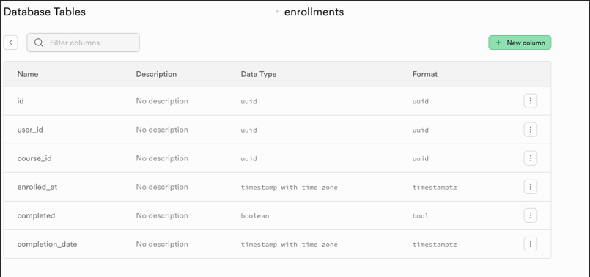

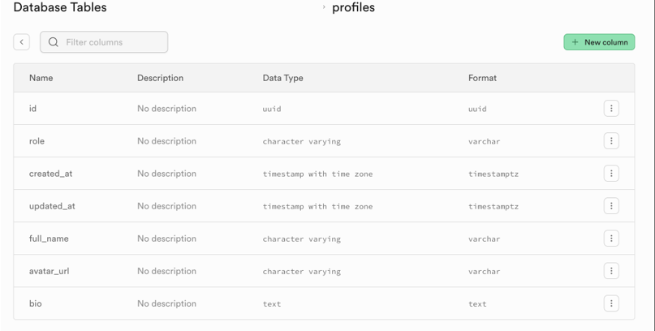 (e.g., **MySQL**,to store user data, courses, assessments, and progress.

## Third-Party Integrations:

Payment gateways (e.g., Stripe, PayPal) for paid courses.

Cloud storage (e.g., AWS S3, Google Cloud) for course materials.

Analytics tools to monitor user engagement and platform performance.

# Conduct Regular Team Meetings to Track Progress

Daily Standups: Quick 15-minute meetings to discuss progress, challenges, and plans for the day.

Weekly Reviews: In-depth discussions on milestones achieved, roadblocks, and adjustments needed.

-Sprint Planning: Using Agile methodology, plan tasks for the next sprint and assign responsibilities.

Tools for Collaboration

Use project management tools like **Jira**, **Trello**, or **Asana**.

Communicate via **Slack** or **Microsoft Teams**.

Share documents and updates on **Google Drive** or **Confluence**.

# 3. Types of Testing

Unit Testing: Test individual components (e.g., login, course upload) for functionality.

-Integration Testing: Ensure all modules work together seamlessly (e.g., user authentication with course enrollment).

System Testing: Test the entire system as a whole to ensure it meets requirements.

Performance Testing: Check the platform’s scalability, speed, and responsiveness under heavy load.

Security Testing: Ensure data encryption, secure authentication, and protection against vulnerabilities (e.g., SQL injection, XSS).

-User Acceptance Testing (

# Challenges and Resolutions

Challenge: Integration of live class features with low latency.

Resolution: Use WebRTC or third-party APIs like Zoom or Twilio.

Challenge: Ensuring platform scalability for a large number of users.

Resolution: Implement load balancing and use cloud services like AWS or Azure.

## Closure Phase

The Closure Phase is the final stage of the project lifecycle, where the system is finalized, tested, and handed over to the end-users. This phase ensures that the project meets its objectives and that the system is ready for deployment. Below is a detailed explanation of each activity in the Closure Phase and how it was executed.

Conduct Final System Testing

Objective: To ensure the system is fully functional, stable, and meets all specified requirements.

Process:

A comprehensive test plan was created, covering all functional and non-functional requirements.

Test cases were executed, including:

Unit Testing: Individual components were tested for correctness.

Integration Testing: Modules were tested to ensure they work together seamlessly.

-System Testing: The entire system was tested as a whole to validate end-to-end functionality.

Performance Testing: The system was tested under load to ensure it meets performance benchmarks.

Security Testing: Vulnerabilities were identified and addressed to ensure data security.

Defects were logged in a bug tracking system (e.g., Jira) and prioritized for resolution.

Outcome:

All critical and high-priority bugs were fixed.

The system was confirmed to be stable and ready for user acceptance testing (UAT).

Prepare a User Manual and Deployment Guide

Objective: To provide end-users and the operations team with the necessary documentation to use and deploy the system effectively.

Process:

User Manual:

- A step-by-step guide was created, explaining how to use the system’s features.

- Screenshots and examples were included to make the manual user-friendly.

- Troubleshooting tips and FAQs were added to address common issues.

Deployment Guide:

- Detailed instructions were provided for deploying the system in different environments (e.g., development, staging, production).

- Prerequisites, such as software dependencies and hardware requirements, were documented.

- Step-by-step deployment procedures, including configuration settings, were outlined.

Outcome:

- The User Manual and Deployment Guide were reviewed and approved by the project team and stakeholders.

- These documents were made available in both digital and printed formats.

Conduct User Acceptance Testing (UAT) and Collect Feedback

Objective: To ensure the system meets the end-users' needs and expectations.

Process

- A UAT plan was created, outlining the scope, test scenarios, and success criteria.

- Selected end-users were invited to participate in UAT.

- Users were provided with test cases and asked to perform real-world tasks using the system.

- Feedback was collected through surveys, interviews, and observation.

Outcome:

- Users reported high satisfaction with the system’s functionality and usability.

- Minor issues and enhancement requests were documented for resolution.

Fix Bugs and Refine the System Based on Feedback

Objective: To address any issues identified during UAT and improve the system based on user feedback.

Process:

- Bugs and enhancement requests were prioritized based on their impact and urgency.

- The development team fixed the identified issues and implemented requested improvements.

- The updated system was retested to ensure the changes did not introduce new defects.

Outcome:

- All critical and high-priority issues were resolved.

- The system was refined to better meet user needs and expectations.

Submit the Final Project Report

## Evaluation Phase

The Evaluation Phase focuses on reviewing the project’s performance, identifying successes and challenges, and capturing lessons learned for future projects.

# Conduct a Post-Project Review

Objective: To evaluate the project’s success and identify areas for improvement.

### Process:

- A post-project review meeting was conducted with the project team and key stakeholders.

- The following questions were addressed:

- What went well?

- The project was completed on time and within budget.

- Effective communication and collaboration among team members.

- The system met all functional and non-functional requirements.

### What challenges were faced and how were they addressed?

Challenge 1: Scope creep due to changing requirements.

Solution: A change management process was implemented to evaluate and approve changes.

Challenge 2:Resource constraints during peak development phases.

Solution: Additional resources were allocated, and tasks were reprioritized.

## Lessons learned for future projects:

- Clearly define and document project requirements upfront.

- Allocate contingency time and budget for unforeseen challenges.

- Regularly communicate with stakeholders to manage expectations.

Outcome:

- The post-project review provided valuable insights into the project’s strengths and weaknesses.

- Lessons learned were documented and shared with the organization to improve future project execution.

## Conclusion

The Closure and Evaluation Phases were successfully completed, ensuring the system was thoroughly tested, refined, and handed over to the end-users. The post-project review highlighted the project’s successes and provided actionable insights for future improvements. This documentation serves as a comprehensive record of the project’s final stages and a guide for continuous improvement in project management practices.